A Philanthropist’s Journeys

Jack Beeler

December 12, 2023

It’s an honor and privilege to speak with you all this evening. In this holiday season of giving, I’d like to talk about just that—giving.

I originally intended for this essay to present the story of an Ohio philanthropist whom I admired—a truly remarkable person, who I will introduce you to later. However, the calamitous collapse of the cryptocurrency exchange FTX last year -- and the self-professed charitable ambitions of Sam Bankman-Fried that contributed to that collapse -- took me in a different direction. As a result, I’d like to compare and contrast two very different kinds of philanthropists and the journeys that they each took.

The trial of Sam Bankman-Fried was in the news for many weeks this fall, and on November 2 he was convicted by a Federal jury in New York City of fraud. He faces the possibility of life in prison. Once touted as one of the richest men in the world, Bankman-Fried’s wealth was once pegged at more than $26 billion. He founded FTX and its intertwined sister organization, the trading firm Alameda Research. Yet, despite his initial financial success, he was found to have defrauded his investors, his employees, his friends, and even his erstwhile girlfriend. With a fortune (at least on paper) like that, why did he do it?

The answer, I’m afraid, is greed to give, a consequence of a “materialist, maximizing-giving philosophy” and “optimized benevolence” called Effective Altruism.

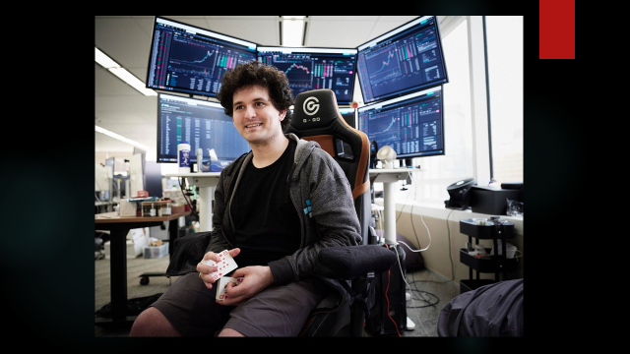

Other high-profile fraudsters--Bernie Madoff, Kenneth Lay, Jeff Skilling—were never associated with any particular philosophical tradition. However, Bankman-Fried famously identified himself as a disciple of Effective Altruism and became the movement’s most prominent donor, promising to eventually give away almost all of his net worth. On multiple occasions, he stated that his consideration for the lives of others aroused his appetite for financial risk. Had he been working merely for his own pleasure, he could easily have comfortably retired a billionaire at a very young age. Instead, he allowed FTX’s customer deposits to be commingled with Alameda’s own funds, where they were used to shore up bad trades and ill-advised investments. The whole operation lost something like $8 to 10 billion, if not more.[1]

I should note here that, after I started work on this essay, I came across the February 20, 2007 Kit Kat essay by our good friend, the late Denny Griffith, who addressed the subject of generosity. Denny’s paper is on the Kit Kat website and is worth a read, for those of you who heard it the first time, and for those of us who didn’t have the pleasure of doing so. Almost 17 years ago, Denny explored various reasons why people are motivated to practice philanthropy. He noted there were more than 600,000 charities and foundations operating in the United States, with charitable donations exceeding $241 billion. Those figures are substantially higher today, according to a study by Bank of America released last October.[2]

Interestingly, the Bank of America report reveals that, while the average amount given to charity by the wealthy continues to go up over time, the percentage of donor households continues to decline. In other words, charities are relying on a smaller number of high-net-worth donors. Interestingly, the study identifies a generational split. Older donors tend to contribute to religious and more conventional organizations because affluent individuals “report a higher degree of confidence in [those] organizations’ abilities to solve societal or global problems.” On the other hand, Millennials and Gen Z givers tend to prioritize issues like climate change and other problems that traditional charitable organizations are less well-equipped to address.

My aim in this essay is to explore whether or not effectiveness is an appropriate measure for philanthropy. Really, Allen Proctor is better qualified to speak on this subject. He has spent a career on it. He was once quoted in Business First as saying that donors should just go with their instincts, and I think he is right about that. In his writings, Allen acknowledges that a charity needs more than billions of dollars to achieve its mission. However, for Sam Bankman-Fried and his fellow Effective Altruists, the objective has been to maximize profits, so as to fund those causes that can make life better for the greatest number of lives. That is what drove Sam to risk the investments in FTX made by large investors, and risk the life savings of thousands of individual crypto investors (including most of his own employees).

What is Effective Altruism?

Originally developed by a philosopher named Peter Singer in 1970[3], “Effective Altruism” (or E.A.) is a utilitarian social movement popularized most recently by a young Oxford University philosopher and author named Will MacAskill.

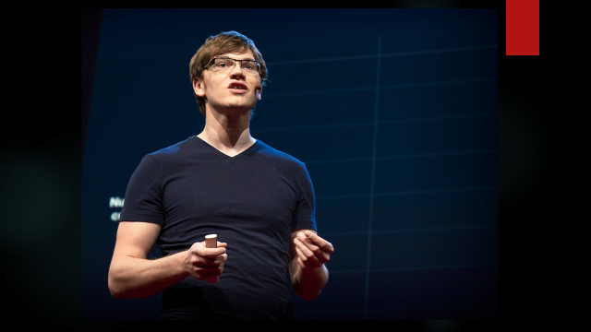

E.A. seeks to ensure that individual gifts measurably do as much good as possible for the betterment of the world.

Back in April 2018, Will MacAskill, born in Scotland and educated at Oxford, gave a TED talk in which he predicted that, if charitable dollars were invested in the right way with the right institutions, it could enhance—and even save--the lives of trillions of people, both now and in the future. MacAskill has been called the “spiritual guru” of Effective Altruism. At the age of 31, MacAskill told his TED audience that, because of the industrial, scientific, and technical revolutions of the Nineteenth and Twentieth Centuries, the Twenty-first Century needs an ethical revolution so that we can figure out how to use our vastly improved economic resources to improve the world. To an Effective Altruist to do the most good, MacAskill said, one can choose to do so through their career, their charitable donations, and their political engagement. Based on his interactions with Will MacAskill, Sam Bankman-Fried became so transformed / indoctrinated / born again to Effective Altruism that he sought to do the most good all three ways—through his business, his giving, and his politics.

Effective Altruism even has its own logo!

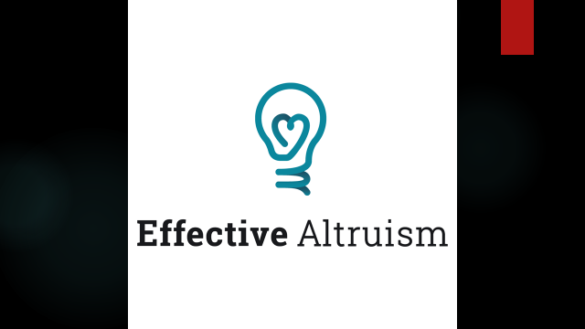 As an evangelist for Effective Altruism, Will MacAskill challenged his audience to determine the biggest, the most easily solvable, and the most neglected problems. Reviewing the most pressing global priorities, MacAskill concluded that global health was the most solvable, so he promoted programs to eliminate malaria through medicines and sleeping nets, to promote routine childhood vaccinations, and to distribute supplements to prevent Vitamin A deficiencies. He also identified factory farming as a seriously-neglected global problem.[4] And finally, he emphasized existential risks like nuclear proliferation, global pandemics, global warming, and unchecked artificial intelligence.

MacAskill and E.A. co-founder Toby Ord have actually quantified those existential risks to humanity. By their estimation, the chances of a stellar explosion are pegged at one in a billion, and the chances of an asteroid strike wiping out life on Earth are one in a million. Not much charities can do about those risks! However, man-made risks like nuclear bombs, climate change, and laboratory-developed pathogens present a one in thirty chance of large-scale damage to mankind, and the risks of runaway artificial intelligence threatening humanity are estimated to be one in ten. (Effective Altruists are highly suspicious of artificial intelligence.)

Bankman-Fried was a true convert, as he gained wide publicity for funding global public health programs. He turned vegan to stand against factory farming. He donated large sums to political campaigns for candidates that stood up for peace and against global warming. But how did he get to that point?

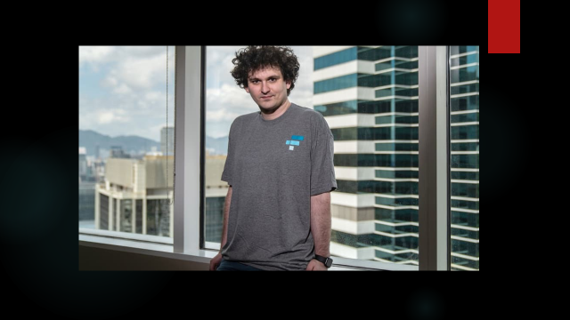Who Is Sam Bankman-Fried?

The son of two Stanford Law School professors, Sam Bankman-Fried was born in 1992 and raised in the Silicon Valley area. After attending a private school, he graduated from MIT with a degree in physics and a minor in mathematics. Bankman-Fried became a disciple of Will MacAskill as early as 2013, when MacAskill encouraged Sam upon graduation to work for Jane Street Capital, a hedge fund in New York, to enhance Sam’s capacity for future philanthropic donations. Sources indicate that Bankman-Fried donated about half of his Jane Street salary to charity. He claimed to make donations "not based on personal interest."

In 2017, Bankman-Fried left Jane Street and started Alameda Research, a hedge fund, with financing from several other Effective Altruists and technical help from California friends. Alameda engaged in quantitative trading, taking advantage of short-term differentials in the price of cryptocurrencies and other assets, mainly in Asia. Within a year, Sam and the entire Alameda staff moved to Hong Kong, to be closer to the trading action. Less than 6 months later, he created FTX. FTX was (and may continue in the future to be) an exchange for traders (and speculators) to buy and sell cryptocurrency and various derivatives. In numerous interviews, Sam explained that FTX was infrastructure to provide liquidity for the crypto marketplace. By 2022, FTX and Alameda had moved to the Bahamas, which purportedly had a more friendly regulatory environment. Sam reportedly discussed the possibility of FTX paying off the Bahamas’ entire $9 billion national debt, to help make that governmental environment even more friendly. From the Bahamas, Bankman-Fried began working to move FTX into the U.S. market.

First appearing on the Forbes magazine billionaires list in 2021, Sam Bankman-Fried at first did not lead a flashy, fashionable lifestyle and actually cultivated a nerdy image. Sam’s brown frizzy hair, cargo shorts, and untucked T-shirt were all part of an image he maintained to make himself look more like an Effective Altruist and less like a spoiled billionaire -- so testified his one-time girlfriend Caroline Ellison in Federal court back in October. She added that Bankman-Fried claimed he'd gotten bigger bonuses while working on Wall Street because of his hair, and he felt his unkempt look was "essential to his image." Caroline Ellison was the former CEO of Alameda Research but struck a plea deal with Federal prosecutors when FTX collapsed.

According to the recent best-selling biography of Bankman-Fried, Going Infinite by Michael Lewis (the author of Moneyball), Sam simply didn’t care what he looked like. He came to realize that his image would promote his commitment to maximizing profits, which could eventually be donated to political and charitable causes. Michael Lewis speculated that Bankman-Fried did not pay close attention to risk management issues at FTX because he was too busy trying to make more money so that he (and his fellow Effective Altruists) could save the world.

Diagnosed with ADHD, Sam was notorious for playing video games while participating in online meetings. He worked with a PR consultant to teach himself how to interact with people and set up a Twitter account in an effort to make himself seem more down-to-earth. Bankman-Fried spent several hours each day on Twitter promoting FTX, the benefits of cryptocurrency trading, and his political and charitable goals. He was campaigning for respectability. Towards the end, he was hobnobbing with Tom Brady and Gisele Bundchen and attending Super Bowl parties and a Met Gala.

I can’t resist adding another footnote here. An article in the Observer earlier this year reported that Bankman-Fried, through the FTX Foundation, had considered "purchasing" the island country of Nauru to use as a bunker in the event of an apocalyptic event. Nauru is located in Micronesia in the South Pacific, and is the third smallest country in the world. According to a complaint filed against Sam by the FTX bankruptcy trustee, the plan was to use the island to construct a “bunker/shelter” that would be used in the event of “some [apocalyptic] event where 50%-99.99% of people die,” creating a haven to “ensure that most [Effective Altruists] survive.” Unfortunately, Sam may never make it to Nauru.

Sam often stated publicly that he built his career in the service of Effective Altruism. Following the guidance of his mentor, he made charitable and political contributions in a big way. Let’s first look at his initial philanthropic efforts:

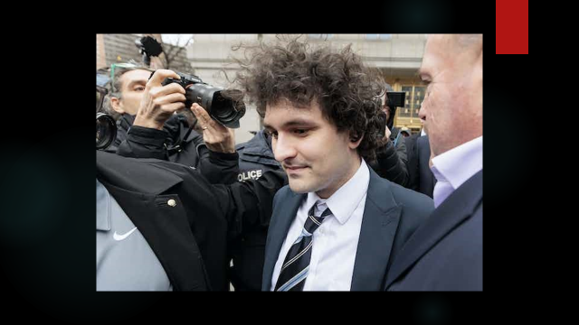Bankman-Fried and his colleagues at FTX handed out $30 million to charitable organizations in 2021, $300 million in 2022, and planned $1 billion in 2023. A charity called “Future Fund” was founded by Sam and Will MacAskill. At the beginning of September, 2022, Future Fund reported assets of about $160 million, which were committed to about 110 nonprofit organizations around the world. Interestingly, after the collapse of FTX on November 11, 2022, all the members of Future Fund simultaneously resigned.[5]

Now let’s turn to Bankman-Fried’s political activism. During the 2020 election, Sam was the second-largest individual donor to Joe Biden, also contributing $5.2 million to 2 super-PACs that supported the Democratic candidate. In a post-FTX collapse interview last December, Bankman-Fried claimed that he also donated large amounts of money to Republicans through dark money channels. Those contributions were not publicly disclosed, he said, because he didn’t want to be hassled by reporters who are all [quote] “super liberal.” The purpose of all these contributions was to position himself as an influential voice in crypto regulation in Washington.

Other famous proponents of Effective Altruism include, remarkably, Elon Musk. Musk has stated that Effective Altruism is “a close match for my philosophy.” Last year, when Musk was seeking outside financing for his purchase of Twitter, Will MacAskill was a go-between for Musk, introducing him to Sam Bankman-Fried as a potential investor. Ultimately, Bankman-Fried did not join in the group funding the acquisition of Twitter, which might have been an early sign that Sam did not have the liquidity that others thought he might have had.

Other Effective Altruists have been in the news recently. According to the New York Times, several members of the Board of Directors of OpenAI have ties to Effective Altruism. OpenAI is the developer of ChatGPT, the artificial intelligence tool that may change the world forever. The OpenAI Board voted last month to oust another Sam--Sam Altman--as CEO of the company. Reflecting their Effective Altruist skepticism about the risk that artificial intelligence poses to humanity, those Board members voted Altman out. Remarkably, within days, the OpenAI Board, under pressure from company employees, welcomed Sam Altman back into the company.

Criticisms of E.A.

One of the key elements of Effective Altruism is that the philanthropist is called to make money in a responsible way, and then give it away responsibly. Critics of Sam Bankman-Fried have been quick to note that he made much of his fortune based on arbitrage (the trading conducted by Alameda Research, of which he was the controlling shareholder). Those critics claim that making a profit based on arbitrage is an irresponsible way to achieve effective philanthropy (especially when using FTX customer funds loaned into Alameda, without the knowledge of those FTX customers).

According to the Chronicle of Philanthropy, the fundamental flaw with Effective Altruism is that it is indifferent to human nature. An article in that publication last December noted that E.A. addresses only physical needs and ignores social, spiritual, and creative needs (which religious and arts organizations address). Rather than acknowledge that charity often stems from emotional impulses (a sense of community, family, and personal interests), Effective Altruism is grounded in strictly analytical information to determine how to do as much physical (as opposed to spiritual) good as possible.[6]

What Approaches Have Other Philanthropists Tried?

Ultimately, Sam Bankman-Fried’s style of philanthropy led him to disrepute and jail. Of course, other high-wealth individuals have been more successful in achieving their philanthropic goals. Back in October came news of the death of Chuck Feeney, who, by the time of his death at age 92, had given away almost his entire $8 billion fortune.[7] Bill Gates and Warren Buffett have long been celebrated for their substantial lifetime gifts.

Most of us are not in the same league with these mega-donors. However, we share a common objective in our philosophy of giving. We want our donations to be meaningful.

Ways to Measure Charitable Effectiveness

There are numerous organizations that critique charities. Many such sites focus on financial statements, highlighting administrative or fundraising costs as a percentage of dollars raised. These reviewers measure the efficiency of philanthropy based on the organizations’ marketing. CharityWatch.org, operated by the American Institute of Philanthropy, a nonprofit watchdog organization, rates charities on a scale of A+ to F. Other online sources of charity data (GivingWhatWeCan.org, CharityNavigator.org, TheLifeYouCanSave.org, and the like) offer varying measuring sticks for charities.[8]

Another way to gauge the effectiveness of charitable giving is through publicly-available information delivered on websites such as the Ohio Attorney General’s Charitable Registration System.[9] Publications ranging from Consumer Reports to Forbes also rate various charities.

Charitable institutions have developed their own mechanisms to promote efficiency. The United Way was originally established to streamline fundraising for smaller nonprofits. Large donors are encouraged to enter into Pledge Agreements that earmark those dollars for particular projects in return for appropriate donor recognition. Community umbrella organizations like the Columbus Foundation counsel charitable donors and their donor-advised funds on the most effective local nonprofits.

The Story of a More Modest Philanthropist

We all want our charitable donations to be used effectively and wisely. I’d like to share the story of one person whose generosity I have long admired, but who did not insist on achieving the greatest good for the largest number of people. Her philosophy of her personal career and her public giving stands in stark contrast to that of Sam Bankman-Fried.

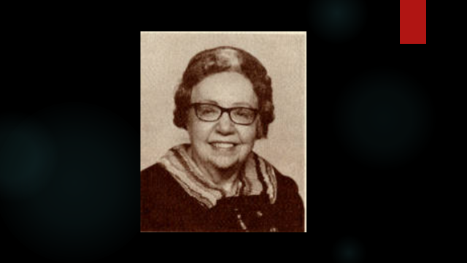 Many years ago, one of my partners was planning on visiting his son in San Diego and looking for a way to make the trip deductible. Before heading off, he asked one of our senior partners if he might visit one of that partner’s clients, who lived out there. Our senior partner had prepared a comprehensive estate plan for the client many years earlier, and he had not been in contact with the client for some time. He agreed that might be a good idea for our colleague to check in with the client while in San Diego. They arranged for a meeting, but it did not go as planned. That was the beginning of my relationship with Margaret Baker.

Upon my partner’s arrival at Miss Baker’s retirement home, the attendants told him how pleased they were that someone was finally visiting Miss Baker. She had been living in San Diego for many years, but no family or friends ever came to see her. She was 87 years old and infirm. She was reputed to be a wealthy woman, but she dressed only in worn housecoats and was in need of significant dental work. She had no companion, and she never left the facility.

When my partner returned to Columbus, we took steps to get Miss Baker the medical care she needed. When she expressed a desire to visit her old home in Ohio, we arranged to bring her back to Springfield, where remarkably her house had been sitting for many years fully furnished, with closets filled with her clothes and jewelry, ready for her return.[10]

Born in 1894, Margaret Baker was the only child of Scipio and Jessie Foos Baker. Her grandfather, Dr. Alonzo Addison Baker, founded The Champion Company in 1878, and it quickly rose to prominence, under the leadership of her father Scipio, as a manufacturer of high quality embalming fluid and funeral products.

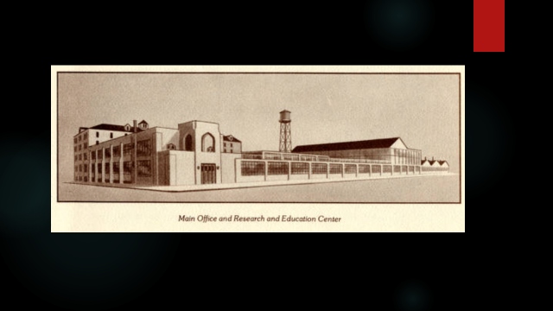

The Champion Company is reported to be the oldest embalming fluid company in the United States. (I suspect that Mike Schoedinger and his family may be familiar with Champion’s products.)

Scipio tragically died in 1921, leaving his widow, Jessie, to run the company as President for many years. Jessie was the daughter of an industrialist who, with Scipio, established the Foos Gas Engine Company in Springfield back in 1887. At the turn of the century, Springfield was one of the leading centers of the fledgling automotive industry, and the Foos Gas Engine Company claimed to be the largest engine manufacturer in the world.[11] Gas engines ultimately proved to be less efficient than the internal combustion engines that Henry Ford and others popularized. Here is an example of a Foos engine, the technology upon which much of Margaret Baker’s fortune was based – quite a contrast from a 21st Century cryptocurrency exchange (which was Sam Bankman-Fried’s intended source of charitable funding):

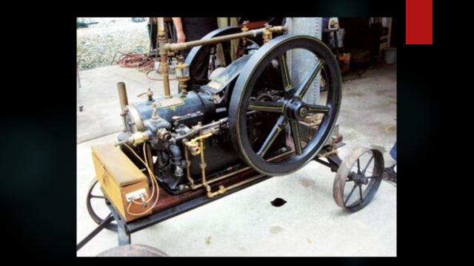

Although the assets of the Foos Gas Engine Company were sold in 1927 and the business moved to St. Louis, the Foos family fortune flourished. Jessie Foos Baker and her daughter Margaret lived very comfortably in Springfield after the death of Scipio.

Margaret claimed to have been taken abroad for the first time when she was 5 years old, and she made at least 10 round-the-world voyages. She travelled extensively in the years between the wars, but she never married. When her mother died in 1946, Margaret became the President of The Champion Company, which by that time was running so smoothly that she could continue her journeys around the world. As a single woman, she travelled to Taiwan, India, the Philippines, Malaysia, Morocco, Thailand, Guatemala, Egypt, and elsewhere. She developed many friendships, including notably one with Generalissimo and Madame Chiang Kai-Shek. Along the way, she began to take color movies of her excursions, which she would edit and for which she would develop narratives. By the late Forties, Margaret had become a noted lecturer, with New York and San Francisco managers booking her travelogues in various venues around the nation. (Here are some brochures featuring Margaret’s film lectures.)

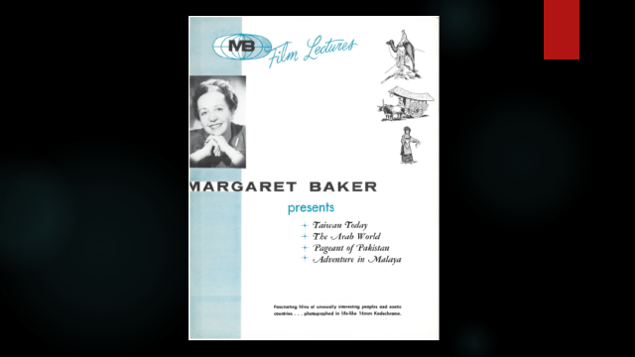

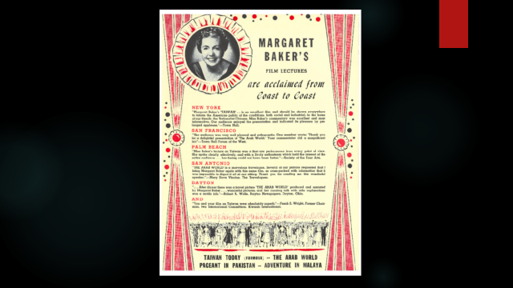 She presented her programs to fairly large audiences in places ranging from Louisiana State University to the Museum of Natural History in New York City.

In the years following World War II, Margaret continued to travel throughout Asia, having bought a rubber plantation in Malaysia during the 1920’s, along with a large farm in Madison County, Ohio. In 1952, she asked my senior partner to develop an estate plan which would leave substantially all of her assets to charity. Having no family of her own, she established a charitable trust in memory of her mother, to benefit charities in and around Springfield.

Like Sam Bankman-Fried, Margaret Baker believed that politics could change the world for good, but rather than donate millions to left-leaning candidates, she donated her time and talents to politicians on the right. She became the Republican National Committeewoman from Ohio, and in 1952, she was one of several speakers to second the nomination of Senator Robert Taft at the Republican National Convention in Chicago. Of course, the convention went on to nominate Dwight Eisenhower for President, and Miss Baker’s political activities wound down in succeeding years.

As the years passed, The Champion Company diversified into other products including shipping containers and supplies such as surgical needles, threads, and injecting machines. The Baker Burglar Proof Metallic Burial Vault, originally invented by Margaret’s father, proved to be especially profitable for the company when, during the Cold War, the United States Defense Department used grave vaults as containers for shipping nuclear missiles around the world. As a defense contractor, Champion earned significant revenue, especially during the Reagan Administration. As a result, The Champion Company had a significant net worth when, at the age of 92, Margaret passed away.

Margaret’s Legacy

Under the Last Will and Testament of Margaret Baker, substantially all of her assets were left to her Charitable Trust, for the specific benefit of the Clark Memorial Home. That bequest in 1986 was worth approximately $5 million – which would equate to more than $13.5 million today. For the object of her bounty, that bequest was gigantic.

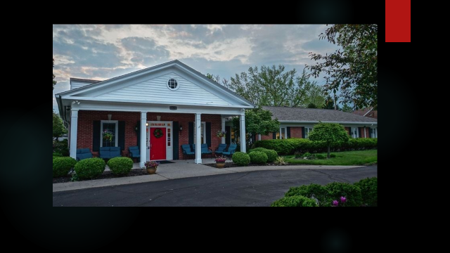 The Clark Memorial Home for Women is located just north of Wittenberg University in Springfield, just a short distance from Margaret Baker’s longtime residence. Originally established in 1899, the current 20-unit senior living facility was constructed in 1960.

Why did Margaret Baker select this small charitable institution in Springfield as the sole beneficiary of her largesse? It is almost the antithesis of what Sam Bankman-Fried and his fellow Effective Altruists have set out to do. Rather than devote her wealth to endeavors that could save millions or billions of lives, Margaret was content to provide a long-term legacy to a residential care center for a limited number of elderly women. Ironically, although she could have lived there herself, she chose to live out her days in San Diego.

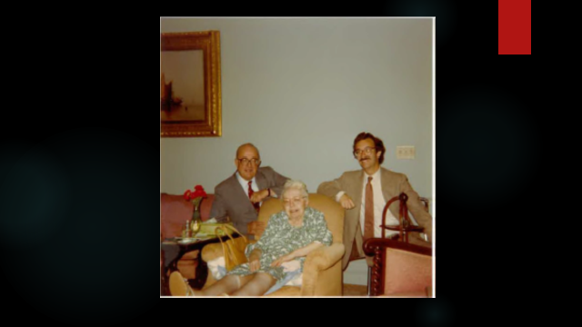 We will never know her thinking on this. Maybe the Executive Director of the Clark Memorial Home was a childhood friend. Maybe some distant family members resided there. I doubt she was ever aware of any concept like “Effective Altruism.” Ultimately, I think she was just honoring her Springfield roots. She had amassed her fortune because her father, the Foos family, and The Champion Company had all prospered locally. She was proud of that legacy, and she probably thought her altruism would be most effective if it stayed local.

Conclusion

In a way, Sam Bankman-Fried and Margaret Baker are opposite extremes. He blasted into prominence as a single-minded entrepreneur, driving his crypto family to achieve higher and higher profits so that, ultimately, he could contribute to progressive political campaigns and target his philanthropy toward visionary programs.

Sam Bankman-Fried’s journey started in Silicon Valley and then moved to Boston, New York, Berkeley, then Hong Kong, and later the Bahamas –always in search of greater profits. Along the way, his charitable giving and political donations were significant. His journey ended in a New York courtroom.

Margaret Baker, on the other hand, inherited a profitable company in Springfield and led it to develop even more profitable lines of business. Travelling the world, she lectured numerous audiences about her journeys to exotic locales. She, too, was active politically.

Sam’s journey landed him in jail. Margaret’s more humble journey ended up peacefully in a nursing home. Arguably, perhaps she was the more Effective Altruist.

Merry Christmas!

22886889v1

1. Ultimately—and ironically--the bankruptcy proceedings for FTX may result in most, if not all, of the monies lost when the crypto exchange closed down in November, 2022, may be recovered. Numerous sources, including author Michael Lewis in his recent podcasts, have reported that the bankruptcy trustee has already clawed back most of the $8 billion lost, and some of SBF’s investments may actually turn out to be more profitable than expected. As a result, the FTX investors may actually be made whole (in spite of Sam’s fraudulent conduct), but the profits that were destined, by the effective altruists, to be channeled to combat pandemics, global warming, and other large-scale threats to humanity will turn out to be illusory.
2. The Lilly Family School of Philanthropy at Indiana University has spearheaded philanthropy education since 1987, establishing the nation’s first bachelor’s, master’s, and Ph.D. degrees in the field. For more than 40 years, an annual study conducted by IU--Giving USA--has published data about our nation’s charitable giving. The Giving USA Report tracks estimated donations given by four different types of donors—individuals, foundations, estates (bequests), and corporations. The 2023 report is more than 350 pages long, providing a baseline for understanding today’s uncertain philanthropic environment.
3. Singer’s book The Most Good You Can Do
4. MacAskill cited the fact that there are 3,000 times more animals in factory farms than there are stray pets.
5. According to Going Infinite, the leaders of the FTX Foundation preferred not to distribute funding to multiple charities:

   “They’d handed out some money but in the process they’d concluded that conventional philanthropy was kind of dumb. Just to deal with the incoming requests—most of which they had no ability to evaluate—would require a big staff and lots of expense. Much of their money would end up being used on a vast bureaucracy. And so they had just recently adopted a new approach: instead of giving money away themselves, they scoured the world for subject matter experts who might have their own, better ideas for how to give away money. Over the previous six months, one hundred people with deep knowledge of pandemic prevention and artificial intelligence had received an email from FTX that said, in effect: Hey, you don’t know us, but here's a million dollars, no strings attached. Your job is to give it away as effectively as you can. The FTX Foundation, started in early 2021, would track what these people did with their million dollars, but only to determine if they should be given even more.”
6. The author of that article in the Chronicle asks:

   “While it may sound noble to overcome personal preference when deciding where to give, is a neighbor in need after her house burns down really less worthy of help than an organization that provides bed nets to protect against malaria in Africa? Giving to that neighbor may not produce the measurable, long-term impact Effective Altruists desire, but the action expresses care, builds social trust, and can encourage others to contribute—further strengthening community bonds.”
7. Mr. Feeney made that fortune in duty-free shops, yet he lived frugally, from wearing a $10 Casio watch to flying economy.
8. In contrast, the EffectiveAltruism.org website promotes a site called GiveWell.org analyzing “the cost-effectiveness of public health interventions.” GiveWell also sponsors a kind of “mutual fund” for donors, the “Top Charities Fund,” that claims to focus on lives saved and impacted per dollar spent, based on empirical evidence.
9. For many years, Ohio had on its books a statute requiring that “charitable trusts” register with the AG’s office. In 2011, the office of newly-elected Attorney General Mike DeWine began aggressively enforcing that statute, as a way to derive revenue to fund the operations of the AG’s Office. The Charitable Institutions Section of the Attorney General’s Office posted a database online, listing all charities that have registered, including summary financial statements, listings of officers and trustees, and other information. Donors now have this online resource to check on how effective their charitable donations may be.
10. When Margaret Baker returned to Springfield from San Diego in 1984, Newsweek magazine had just celebrated its 50th anniversary. In its Golden Anniversary edition, the magazine featured Springfield as the typical American town.
11. Foos engines were sold globally, and the company even developed a diesel engine suitable for automobiles and other vehicles.